CONFUSION MATRIX

Confusion matrix is used to describe the performance if a classification. To implement this, we used a dataset of spam and ham emails. Using, the algorithm, we were able to create a predicted and actual values for if an email is a spam or an ham. Image below:

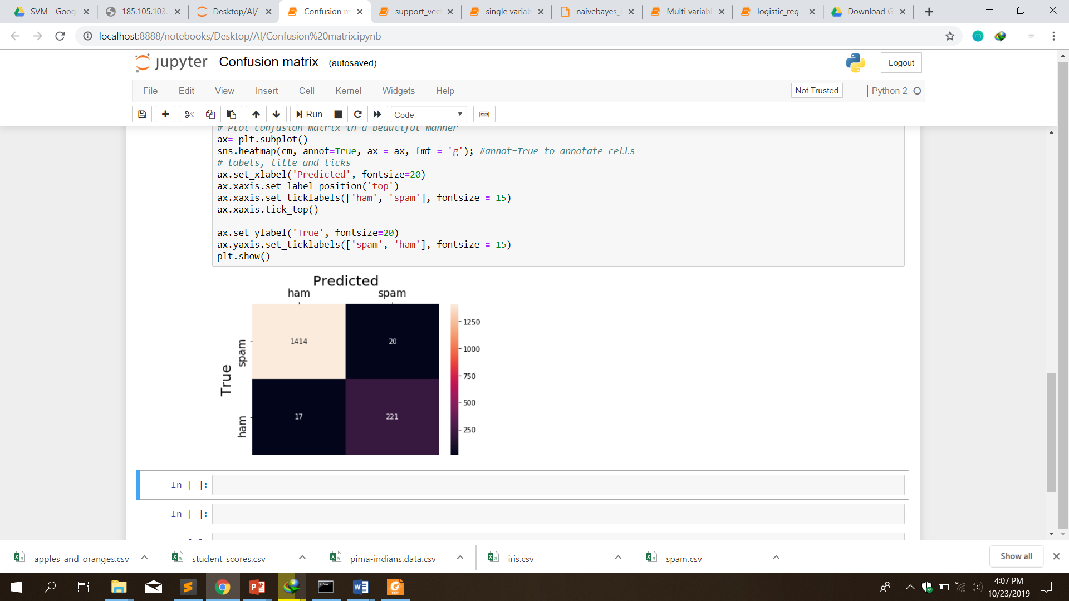

From the above diagram, crossing the actual(true) against the predicted value, we can se the probability that an incoming mail will be an ham or a spam. On the right is the concertation map of the mail.